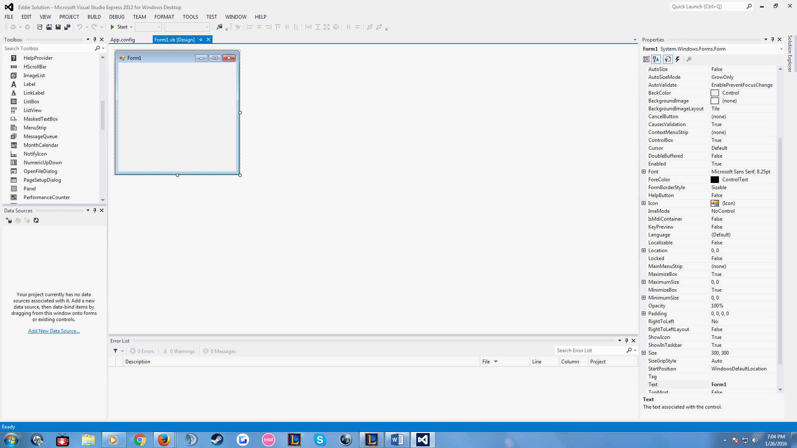

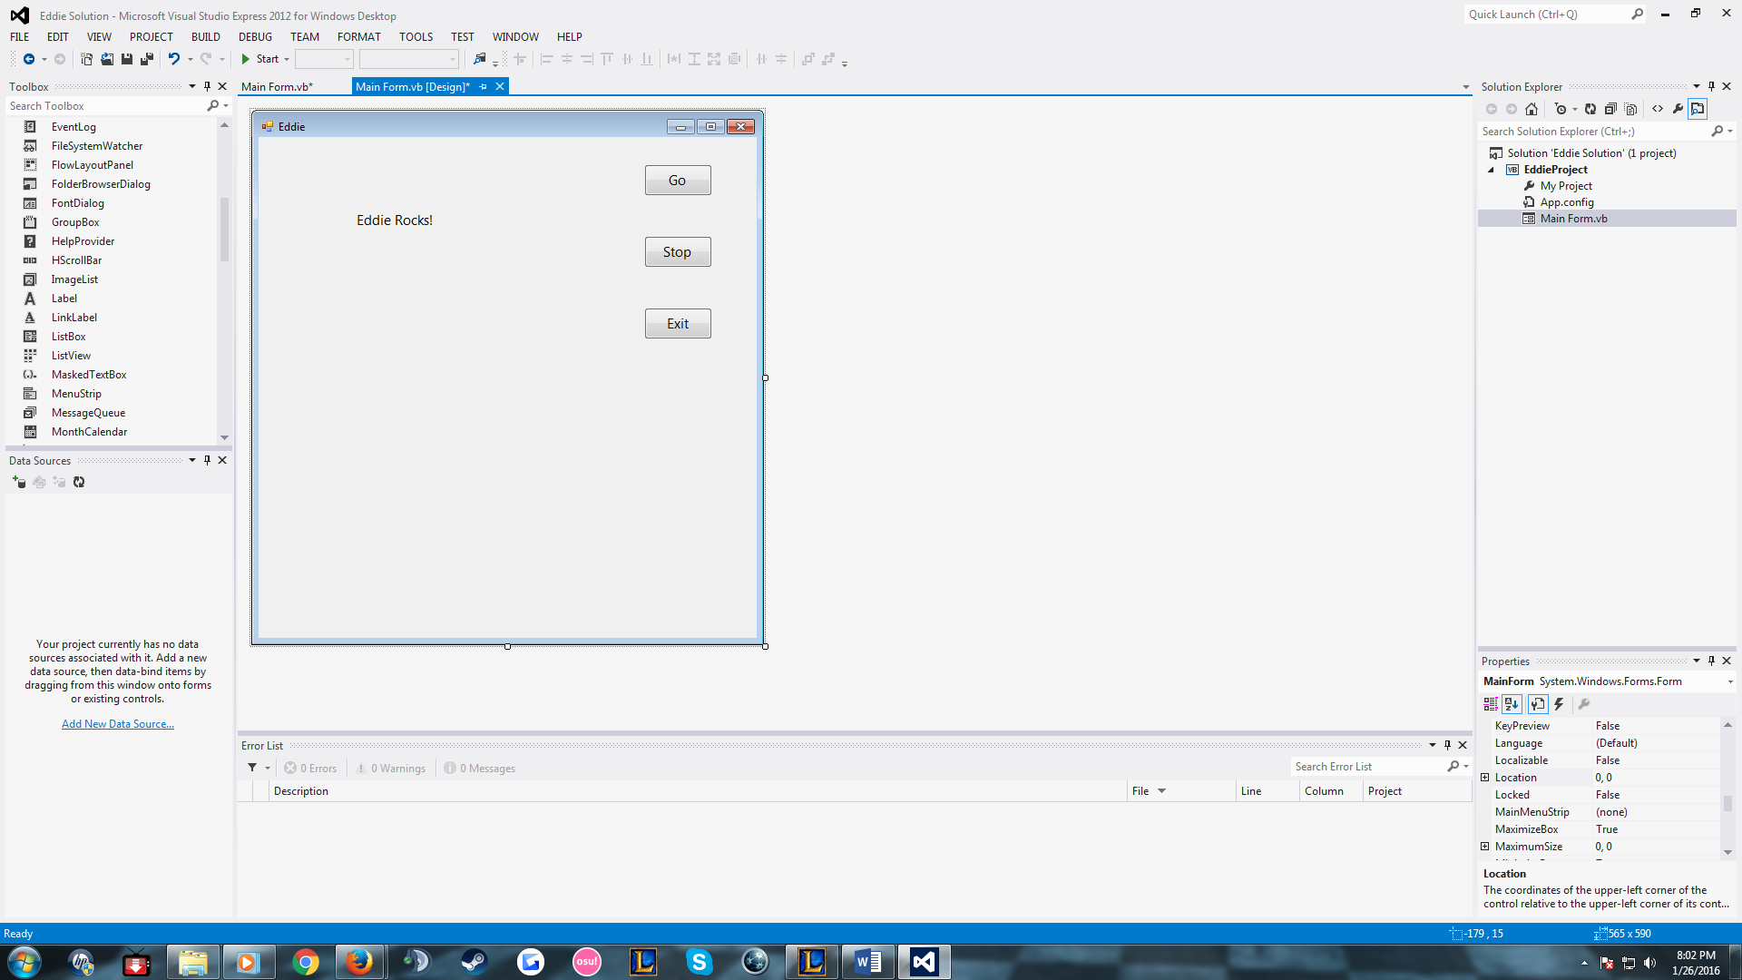

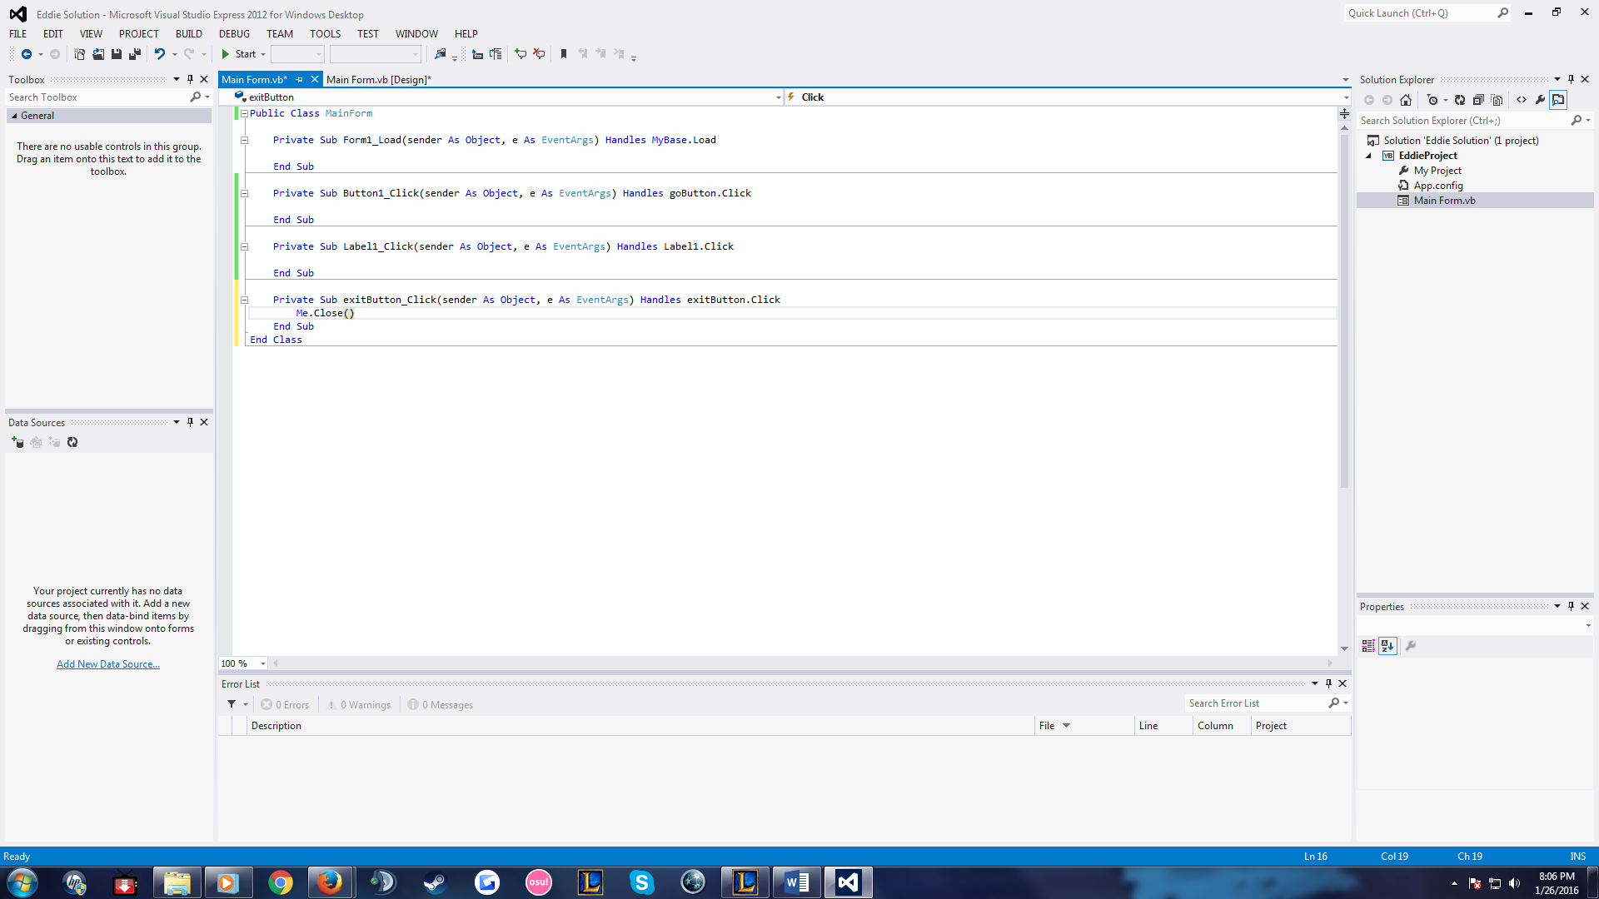

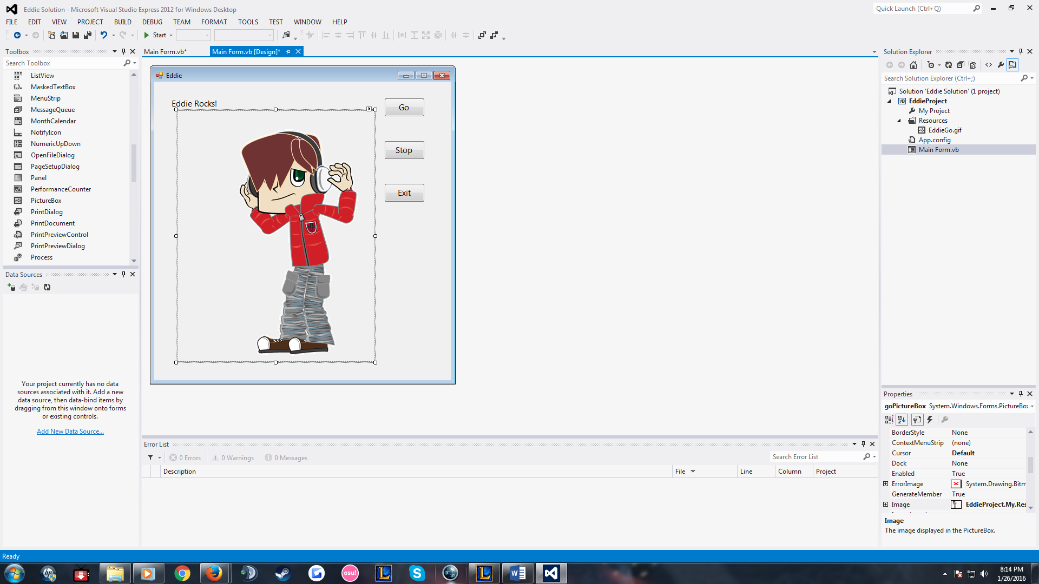

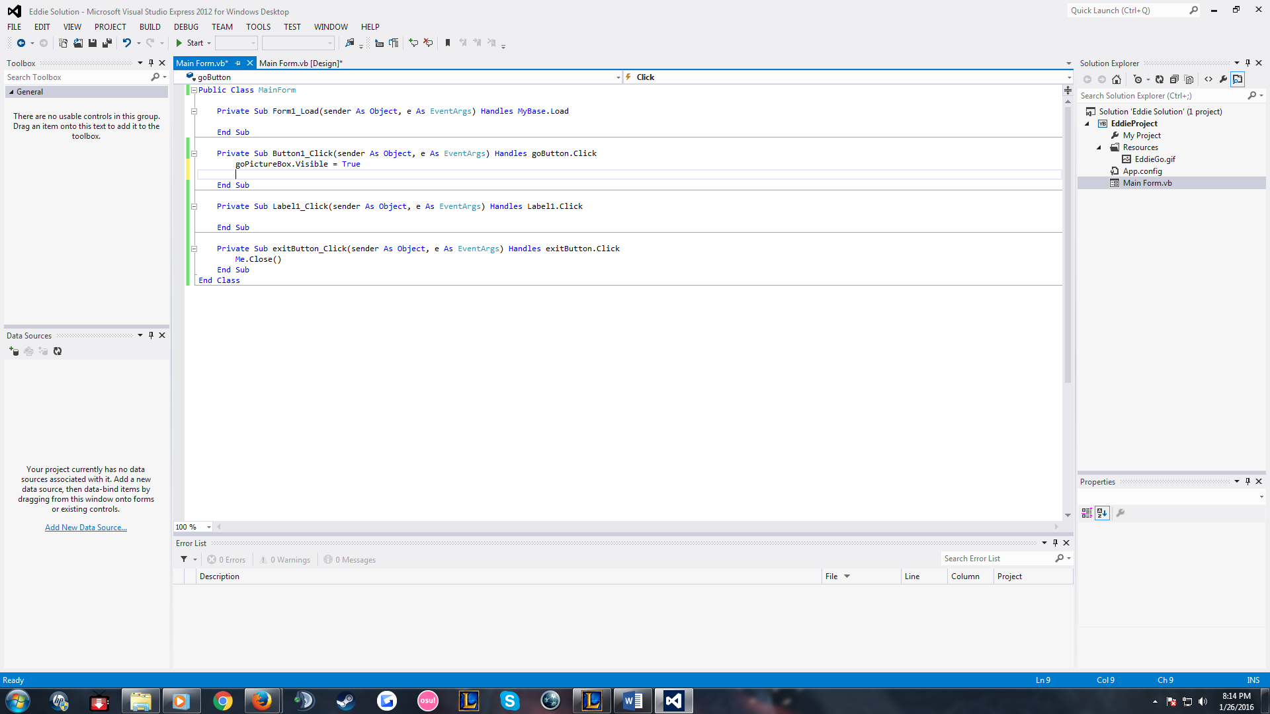

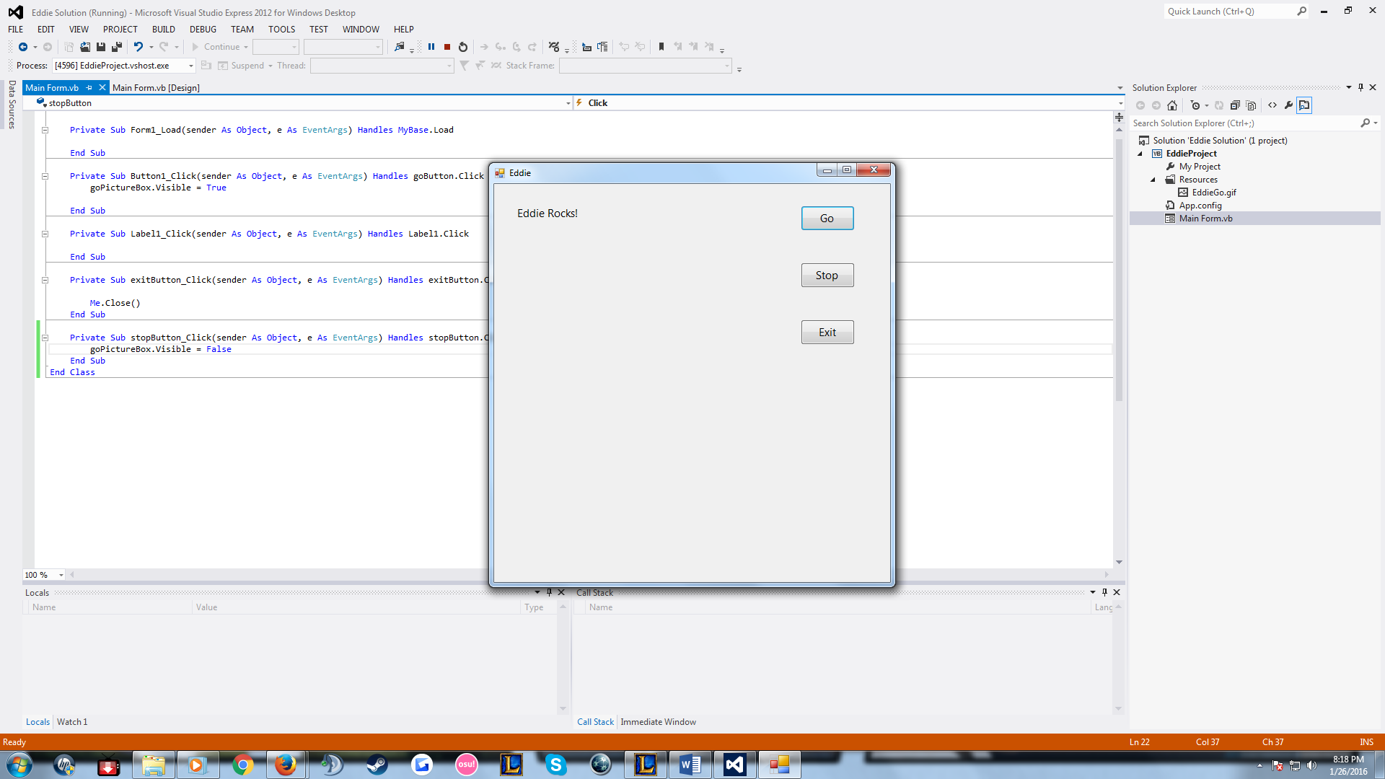

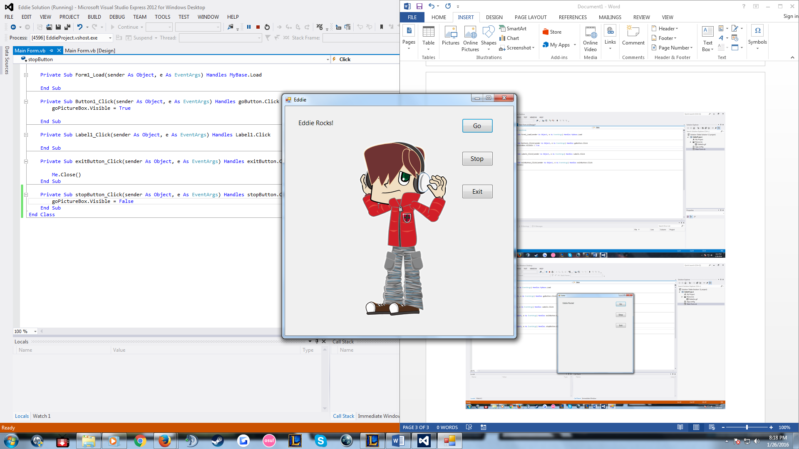

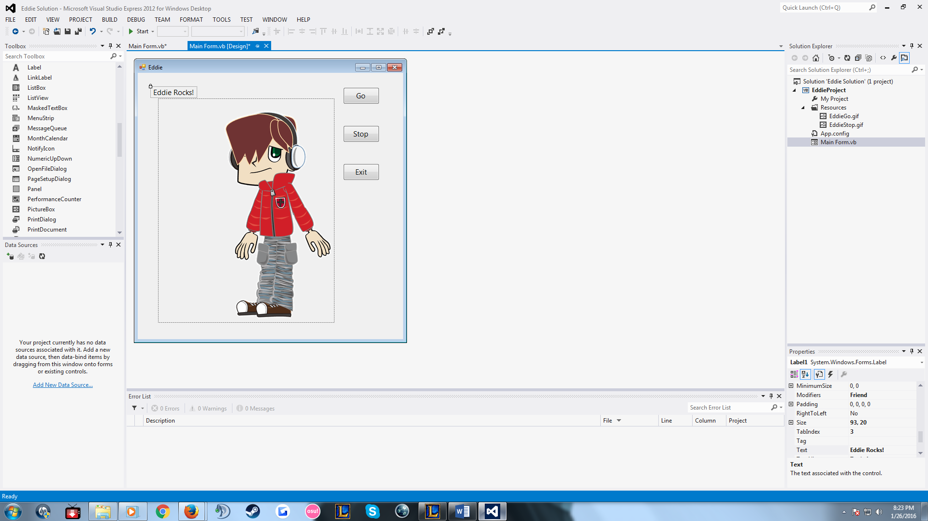

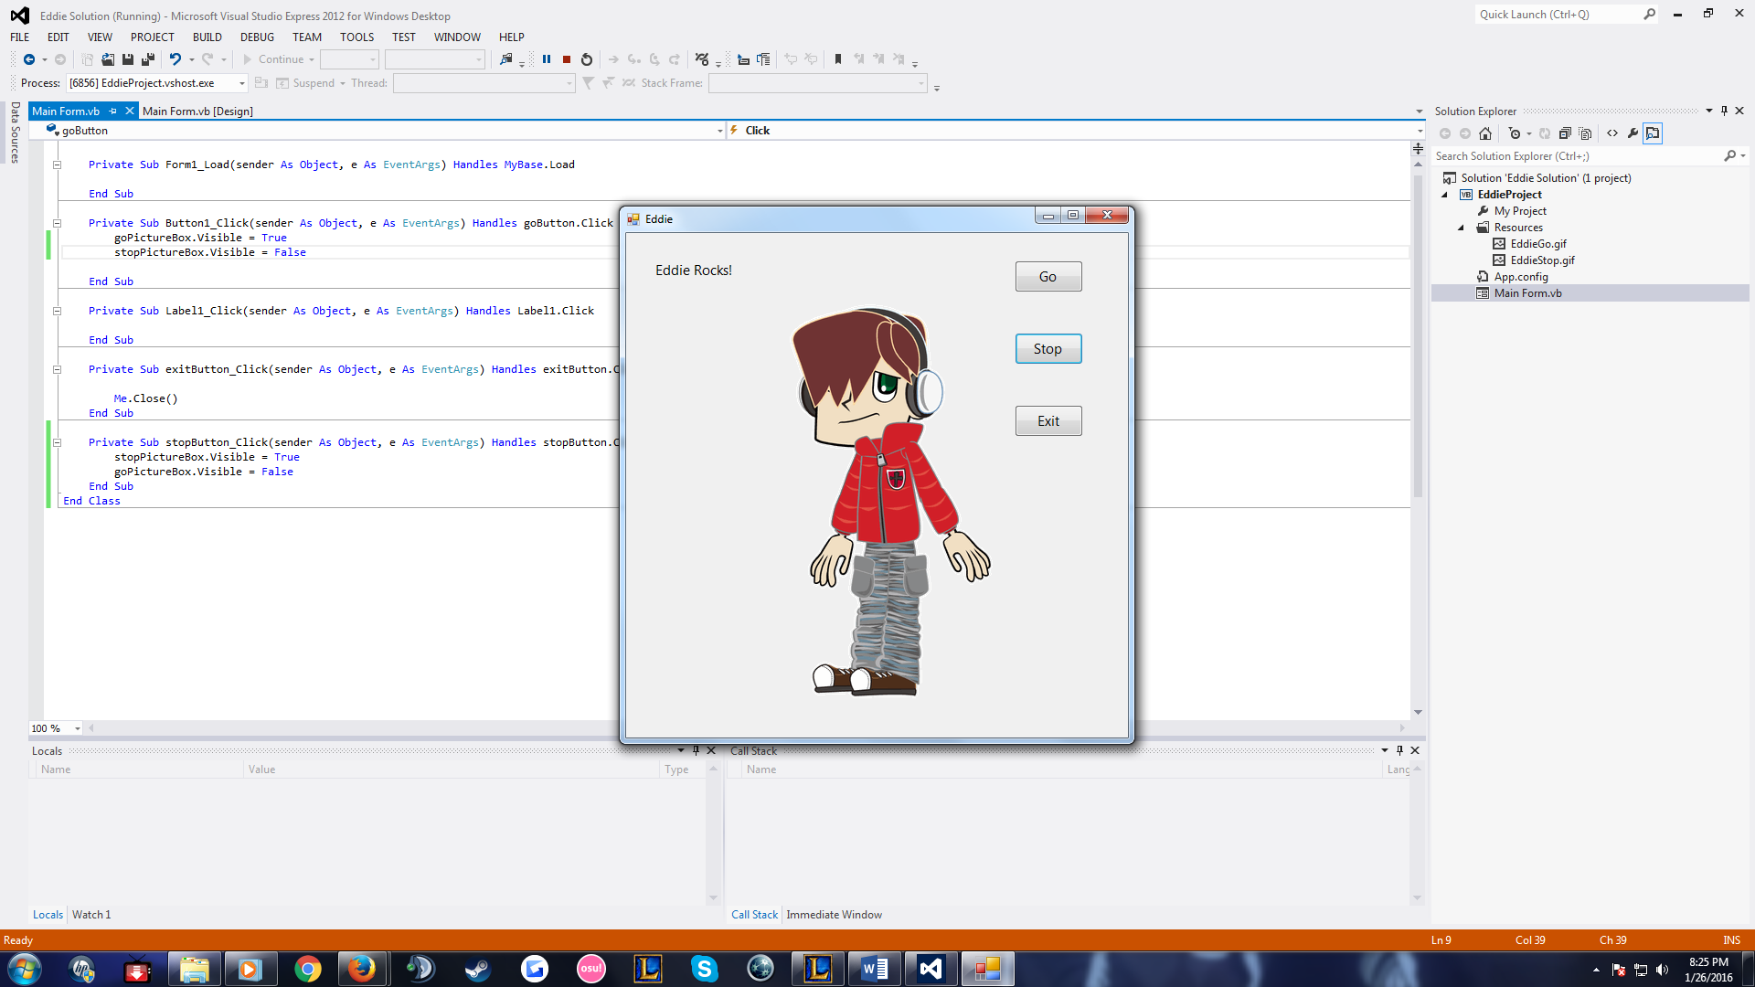

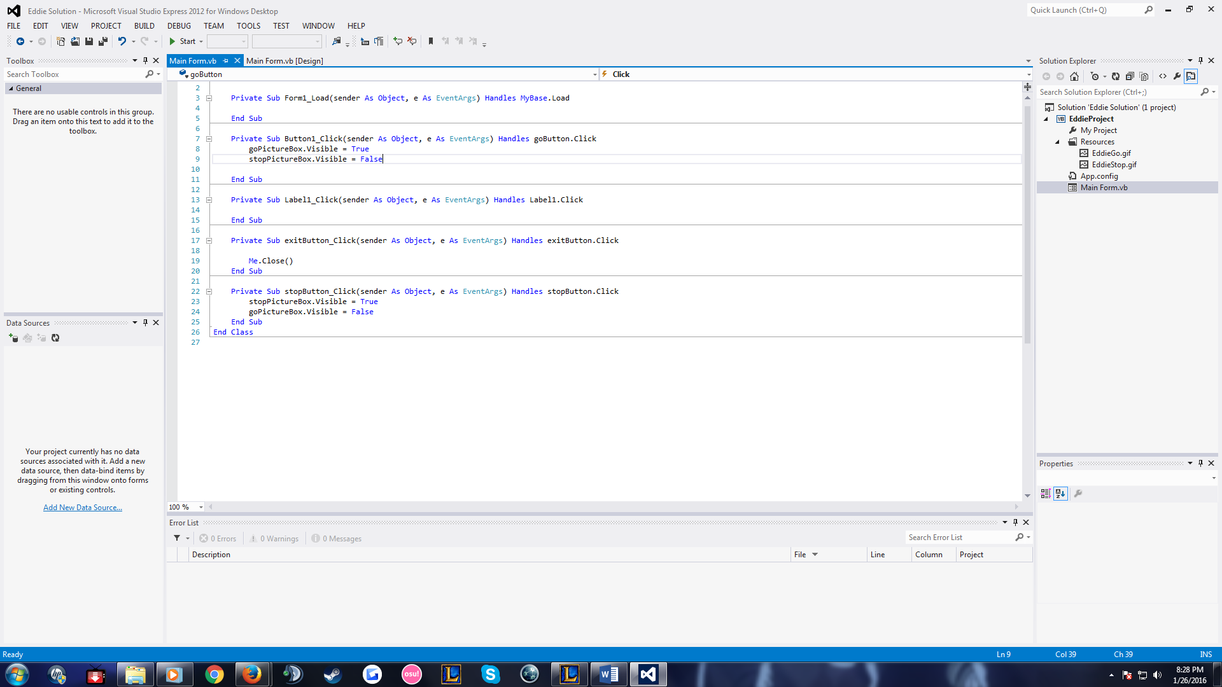

Public Class MainForm

Private Sub Form1_Load(sender As Object, e As EventArgs) Handles MyBase.Load

End Sub

Private Sub Button1_Click(sender As Object, e As EventArgs) Handles goButton.Click

goPictureBox.Visible = True

stopPictureBox.Visible = False

End Sub

Private Sub Label1_Click(sender As Object, e As EventArgs) Handles Label1.Click

End Sub

Private Sub exitButton_Click(sender As Object, e As EventArgs) Handles exitButton.Click

Me.Close()

End Sub

Private Sub stopButton_Click(sender As Object, e As EventArgs) Handles stopButton.Click

stopPictureBox.Visible = True

goPictureBox.Visible = False

End Sub

End Class